IPS WSO w. Email Deployment
This guide explains how to deploy the WSO2 Identity Server container on a new host using Docker Compose.
It covers preparing the external database volume, configuring the service, and running the container.

Overview
The deployment uses a Docker Compose file that defines the wso2is service.
This service uses the wso2/wso2is:5.10.0-alpine3.11 image, maps necessary ports, sets environment variables, and mounts configuration files and an external volume for persistent database storage.

Prerequisites
- Extract all relevant client domain data available from existing WSO deployed
- ADSI Editor in DC contains mapping of Distinguished names required in the table below:

Field | Data [Replace w. Deployment details]
Platform URL | https://specterx.10lab.local
Domain Name | 10lab.local
Hostname | spx-auth.10lab.local
Server IP (SSH) | 10.0.0.36
Client IP (RDP) | 10.0.0.42
DC Name + FQDN | dc.10lab.local
LDAP Connection URL | ldap://dc.10lab.local:389
User Search Base  Distinguished name | CN=Users,DC=10lab,DC=local
Connection Name  SpecterX Service Account DN \  Distinguished name | CN=Specterx,CN=Users,DC=10lab,DC=local
SPN@DC-FQDN  Service Principal Name: | HTTP/spx-auth.10lab.local@dc.10lab.local
SPN Password | Aa123456
User Entry Object Class | user
Username Attribute | sAMAccountName
User Search Filter | (&(objectClass=user)(sAMAccountName=?))
User List Filter | (objectClass=user)

- Docker: Installed on your host.
- Docker Compose: Installed on your host.
- External Volume: The external Docker volume wso-db-vol must be created or available for persistent database storage.
- Configuration Files: Ensure you have the necessary configuration files
└── wso2
├── conf
│ ├── deployment.toml
│ └── userstores
├── docker-compose.yaml
└── wso-db-vol
├── WSO2CARBON_DB.mv.db
├── WSO2IDENTITY_DB.mv.db
├── WSO2METRICS_DB.mv.db
├── WSO2SHARED_DB.mv.db
└── jpadb.mv.db



Stop The Service

cd /opt/specterx #change dir
docker ps #view running procceses
docker compose down wso2 #bring wso2 down

Docker Compose File
Below is the Docker Compose file you will use:
Change dir to our platform
cd /opt/specterx
nano docker-compose.yml
cd to the folder copied
cat wso2/docker-compose.yml
And paste it into the current place
 wso2:
image: "wso2/wso2is:5.10.0-alpine3.11"
container_name: wso2
ports:
- "9763:9763"
- "4000:4000"
- "9443:9443"
environment:
- JAVA_OPTS=-Xms512m -Xmx1024m
volumes:
#- /opt/specterx/conf/userstores:/home/wso2carbon/wso2is-5.10.0/repository/deployment/server/userstores
- /opt/specterx/conf/deployment.toml:/home/wso2carbon/wso2is-5.10.0/repository/conf/deployment.toml
- wso-db-vol:/home/wso2carbon/wso2is-5.10.0/repository/database

volumes:
wso-db-vol:
external: true

Setting Up the Database Volume
The external volume "wso-db-vol" is used to persist database data. Follow these steps to set up the volume and deploy the container.
1. Create the External Volume
If the volume does not exist, create it by running:
docker volume create --name wso-db-vol
Verify the volume was created with:
docker volume inspect wso-db-vol
You should see output similar to:
[
{
"CreatedAt": "2025-03-06T19:43:36+02:00",
"Driver": "local",
"Labels": null,
"Mountpoint": "/var/lib/docker/volumes/wso-db-vol/_data",
"Name": "wso-db-vol",
"Options": null,
"Scope": "local"
}
]
Copy DB data into the volume:
Make sure you have the DB dump available in your working dir, and then move it to the created wso-db-vol path:
cd wso2/wso2
sudo cp wso-db-vol/* /var/lib/docker/volumes/wso-db-vol/_data/
Change file permissions to match wso2 internal service user:
sudo su
cd /var/lib/docker/volumes/wso-db-vol/_data/
ls -l
chown 802:802 *
exit
Copy all the files from the imported folder (wso2) to the containers folders:
sudo mkdir /opt/specterx/conf
sudo cp -r conf/* /opt/specterx/conf/

2. Edit & Deploy the Container
Prepare Your Configuration Files:
Ensure the following files and folders are in the same directory as your docker-compose.yml file:
sudo su
cd /opt/specterx/conf
- /opt/specterx/conf/deployment.toml - file
- /opt/specterx/userstore - dir

Modify Deployment Settings:
Change the following parameters in your deployment.toml file to match the required settings:
[server]
hostname = "spx-auth.specterxlab.com"
node_ip = "192.168.111.23"
base_path = "https://$ref{server.hostname}"

[transport.https]
port = 9443 # IS listen port

[transport.https.properties]
proxyHost = "spx-auth.specterxlab.com"
proxyPort = 443

Modify Kong yaml:
Add another plugin setting:
- name: request-transformer
service: AUTH
config:
add:
headers:
- "X-Forwarded-Proto: https"
- "X-Forwarded-Port: 443"
- "Host: spx-auth.10lab.local"

Restart kong container and validate its up w. no errors.
Start the Container:
Run the following command from the directory containing your docker-compose.yaml:
cd /opt/specterx
docker compose up -d wso2

This command starts the container in detached mode.
Verify the Container is Running:
Check the running containers with:
docker ps
# to view logs
docker logs -f wso2
Confirm that the wso2 container is active and ports 9763, 4000, and 9443 are correctly mapped.

3. Accessing the Application
Open your browser and navigate to:
https://<SpecterX-Auth-DNS-Name>:9443/carbon/
This will open the WSO2 Identity Server management console.
Login to the WSO2 Identity Server using the following credentials: admin@admin.

4. Configure the WSO according to the guide

4.1. Create User Store
On the left-hand side of the screen, locate the ‘User Stores’ section and click on ‘Add’.
Use the following table as a reference while creating the new User Store:
Setting Name | Value
User Store Manager Class | org.wso2.carbon.user.core.ldap.ReadWriteLDAPUserStoreManager
Domain Name | <Organization-Domain-Name> (I.E - specterxlab.com)
Connection URL | ldap://<Domain-Controller-FQDN>:389  (I.E - ldap://DC-01.specterxlab.com:389)
Connection Name | <SpecterX-Service-Account-User-DN>  (I.E - CN=wsouser,OU=spxusers,DC=specterxlab,DC=com)
Connection Password | <SpecterX-Service-Account-Password>
User Search Base | <Users-OU-DN>  (I.E - OU=spxusers,DC=specterxlab,DC=com)
User Entry Object Class | user
Username Attribute | sAMAccountName
User Search Filter | (&(objectClass=user)(sAMAccountName=?))
User List Filter | (objectClass=user)
Note - Please leave ‘Optional’ and ‘Advanced’ as is.
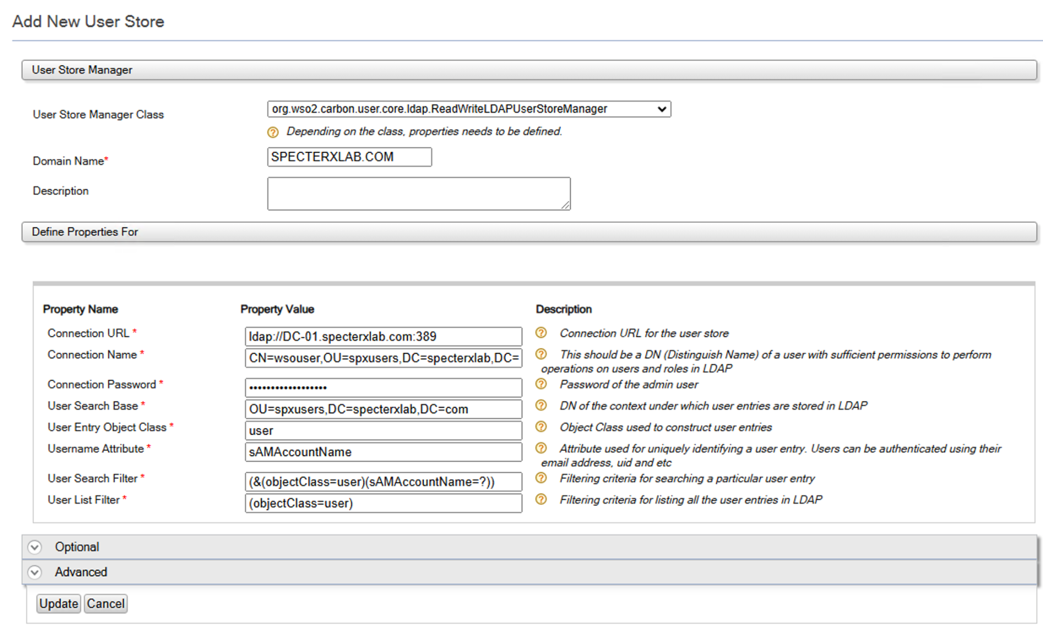
Navigate to ‘Users and Roles’ and click on ‘List’ and then ‘Users’ to validate the WSO is able to read user data from the Active Directory.
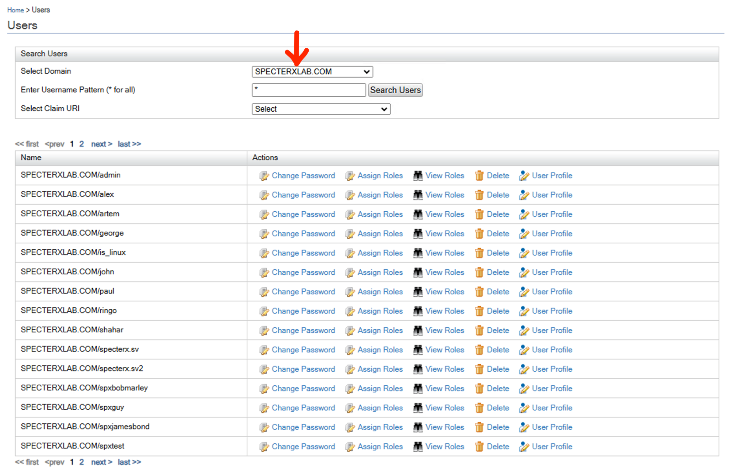

4.2. Create Identity Provider
On the left-hand side of the screen, locate the ‘Identity Providers’ section and click on ‘Add’.
Use the following table as a reference while creating the new Identity Provider:
Setting Category | Setting Name | Value
General | Identity Provider Name | <Organization-DC-FQDN>
 | Alias | https://<SpecterX-Auth-DNS-Name>/oauth2/token  (I.E - https://spx-auth.specterxlab.com/oauth2/token)
Claim Configuration | Basic Claim Configuration | Select ‘Use Local Claim Dialect’  User ID Claim URI: http://wso2.org/claims/addresses
Federated Authenticators | SAML2 Web SSO Configuration | NameID format: validate default is:  urn:oasis:names:tc:SAML:1.1:nameid-format:unspecified
 | OAuth2/OpenID Connect Configuration | Callback Url: validate default is:  https://<SpecterX-Auth-DNS-Name>:9443/commonauth
IWA Kerberos Configuration | Enable | True
 | Service Principal Name | <SPN-For-SpecterX-Auth>  (I.E - HTTP/spx-auth.specterxlab.com@DC-01.specterxlab.com)
 | Service Principal Password | <SpecterX-Service-Account-Password>
Just-in-Time Provisioning  JIT | Always provision to User Store Domain | Select the Userstore you created with the domain name  [SPECTERXLAB.COM]
 | Provision silently | True

The following figures show a valid configuration (For SpecterXlab.com domain)
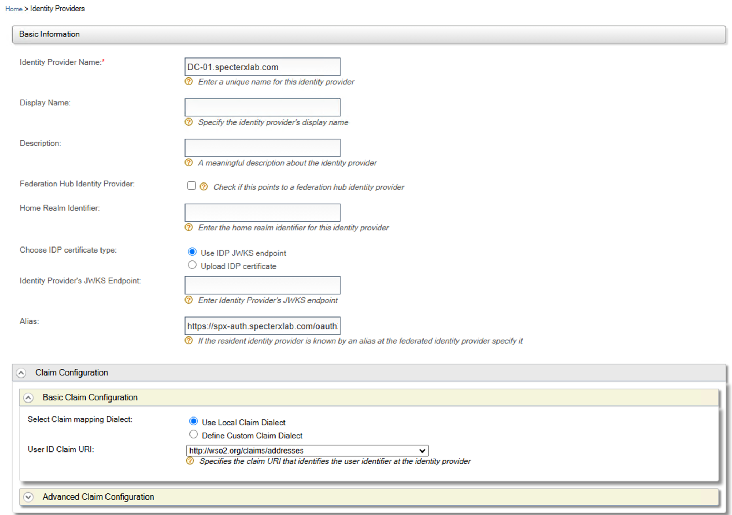

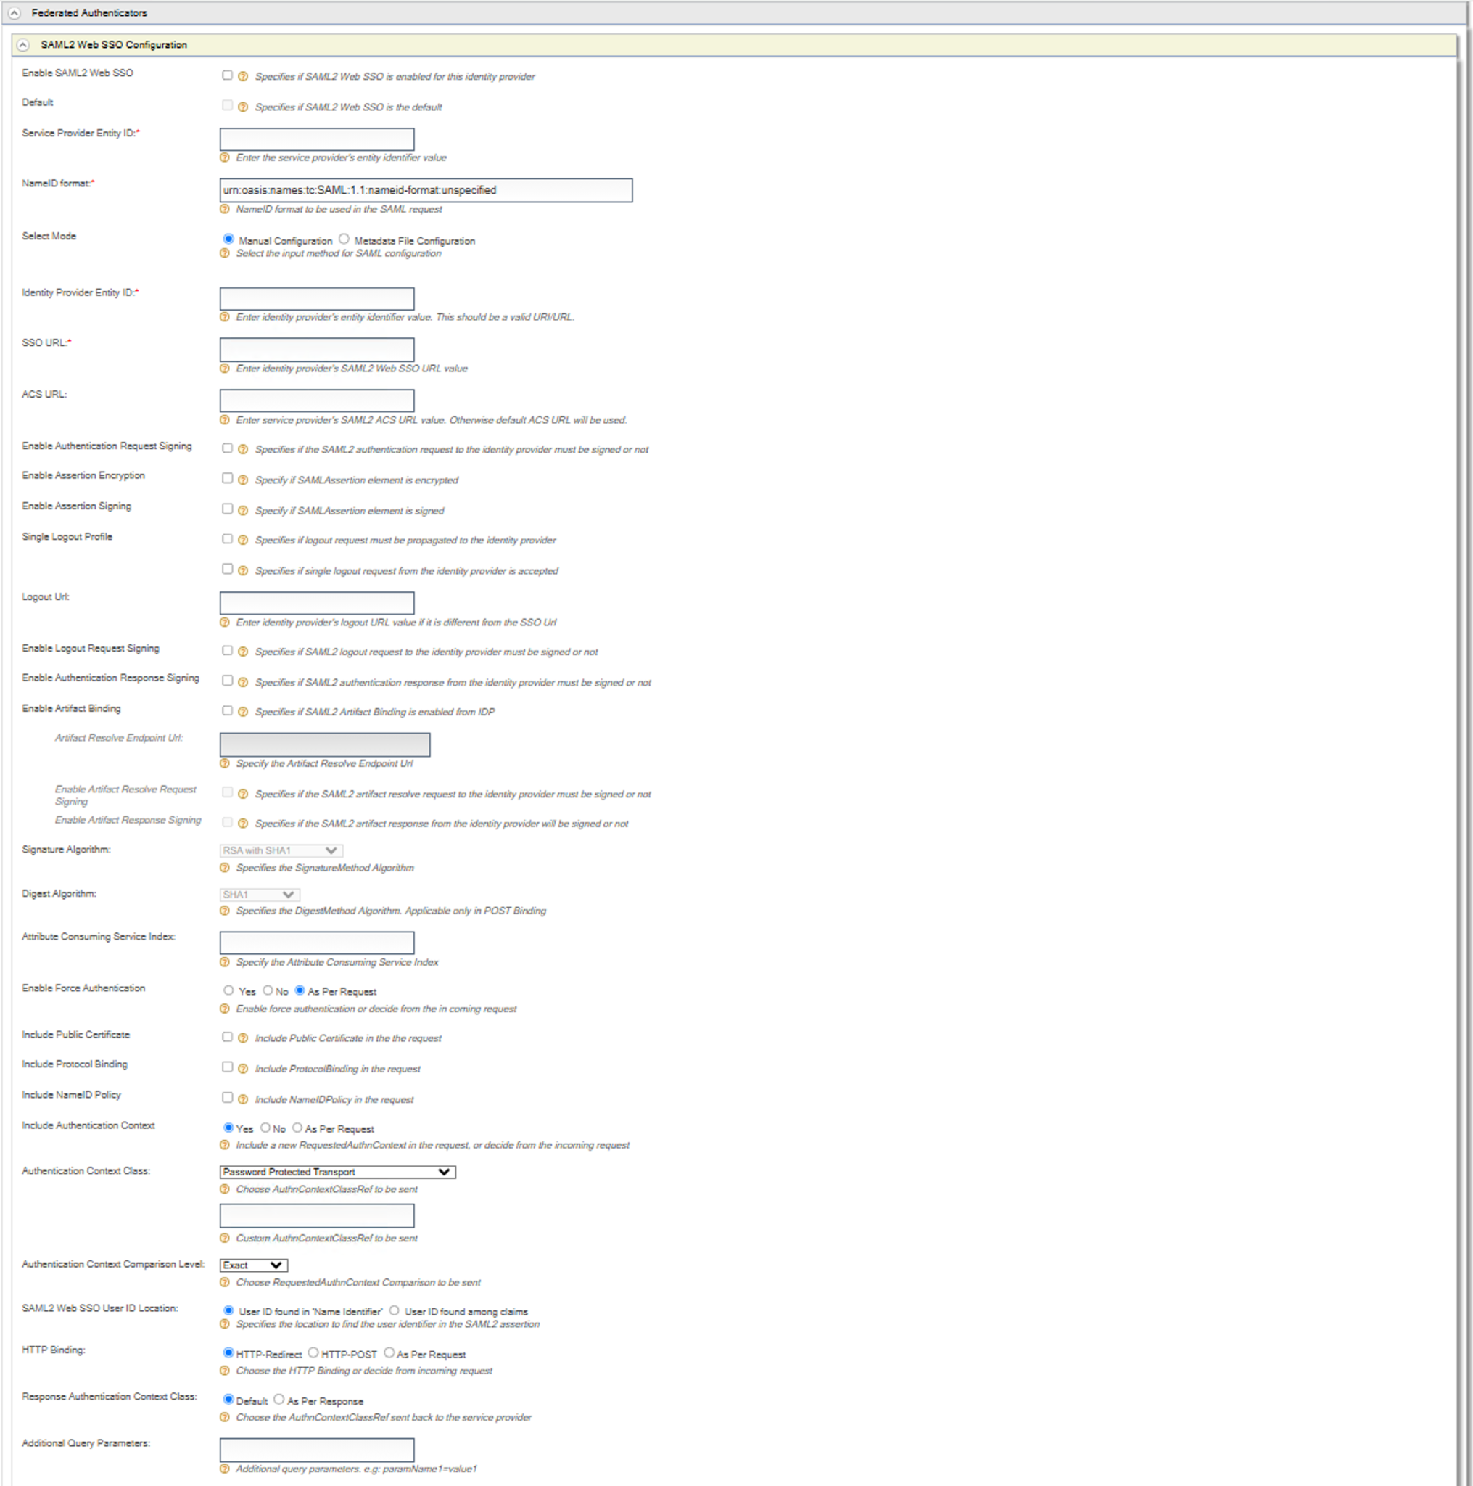

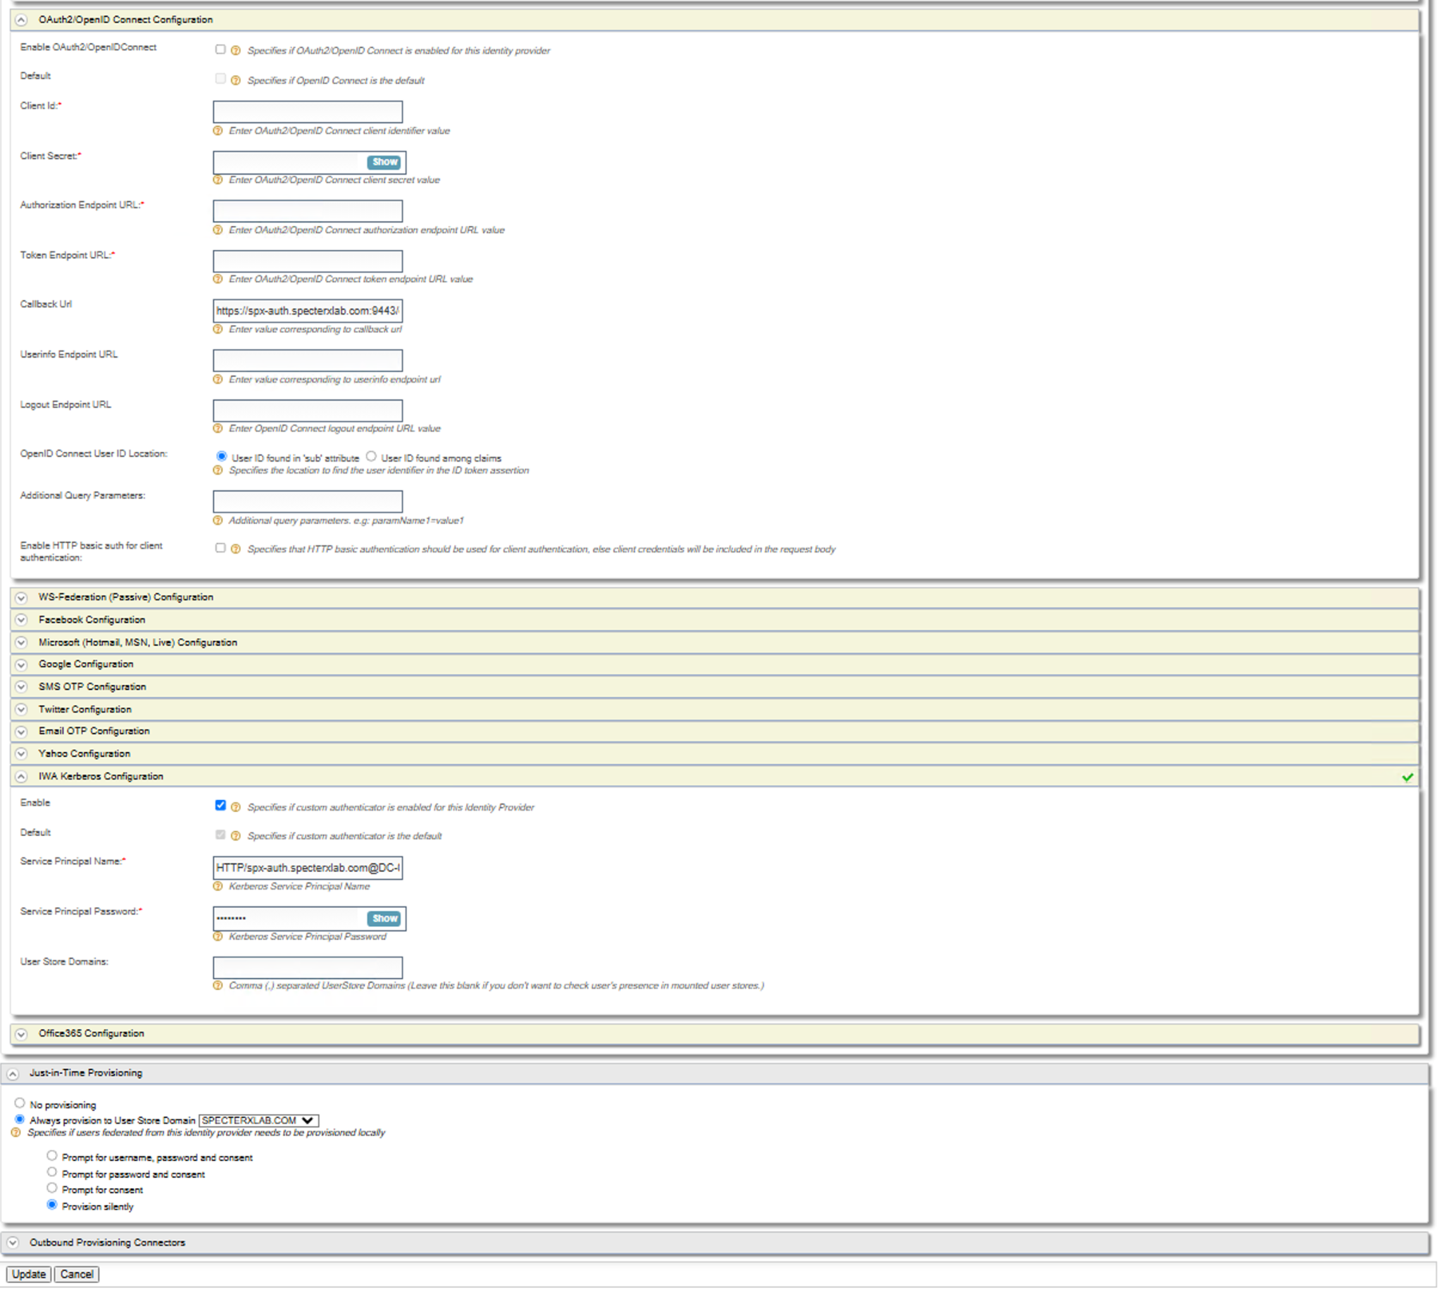

Validate\Update resident claims
In Identity providers > Residents > Inbound Authentication Configuration > OAuth2/OpenID Connect configuration

Make sure the value is: https://spx-auth.DOMAIN/oauth2/token
Without trailing port number:
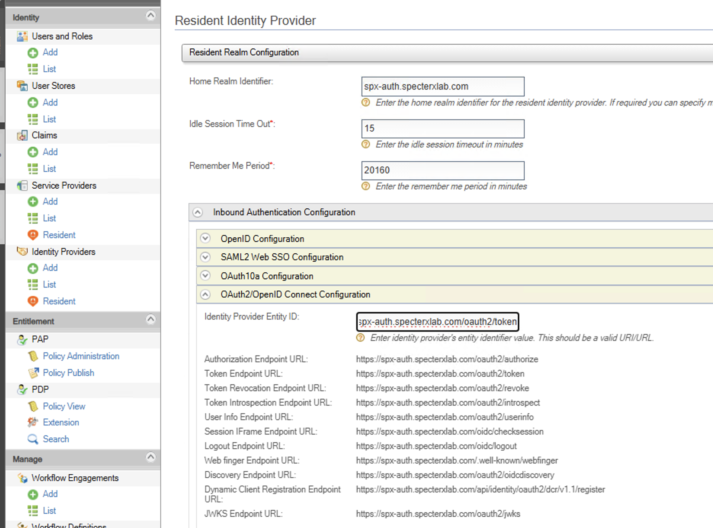
Register or Update the values

4.3. Create Service Provider
On the left-hand side of the screen, locate the ‘Service Providers’ section and click on ‘Add’, select ‘Manual Configuration’.
Use the following table as a reference while creating the new Service Provider, or edit the existing web-client:
Setting Category | Setting Name | Value
General | Service Provider Name | web-client
 | Description | SpecterX Web Application
 | Access URL | https://specterx.DOMAIN-NAME
Claim Configuration | Define Custom Claim Dialect  Validate defaults: | Add two claim URI’s with the following settings:  Validate defaults:  Service Provider Claim Local Claim requested claim  groups http://wso2.org/claims/role V  email http://wso2.org/claims/emailaddress V
 | Subject Claim URI  Validate defaults: | email
Inbound Authentication Configuration | OAuth/OpenID Connect Configuration | Create a new one or edit with the following configurations:  OAuth Version code, implicit, Password, Client Credential, Refresh Token, urn:ietf:params:oauth:grant-type:jwt-bearer  Callback Url Change the domain name From specterxlab.com to match deployment regexp=(https://specterx.specterxlab.com|http://localhost:3000)  Token Issuer JWT
OpenID Configuration | OpenID Realm  Validate defaults: | web-client
WS-Federation (Passive) Configuration | Passive STS Realm  Validate defaults: | web-client
Kerberos KDC | Service Principal Name | Create or delete the existing one and create a new one, ignore errors on delete.  <SPN-For-SpecterX-Auth>  (I.E - HTTP/spx-auth.specterxlab.com@DC-01.specterxlab.com)
Local & Outbound Authentication Configuration | Authentication Type:* | Switch Federated Authentication - and select Domain controller name (I.E - DC-01.specterxlab.com)
 | Skip Login Consent | True
 | Skip Logout Consent | True
 | Assert identity using mapped local subject identifier | True

The following figures show a valid configuration (For SpecterXlab.com domain)
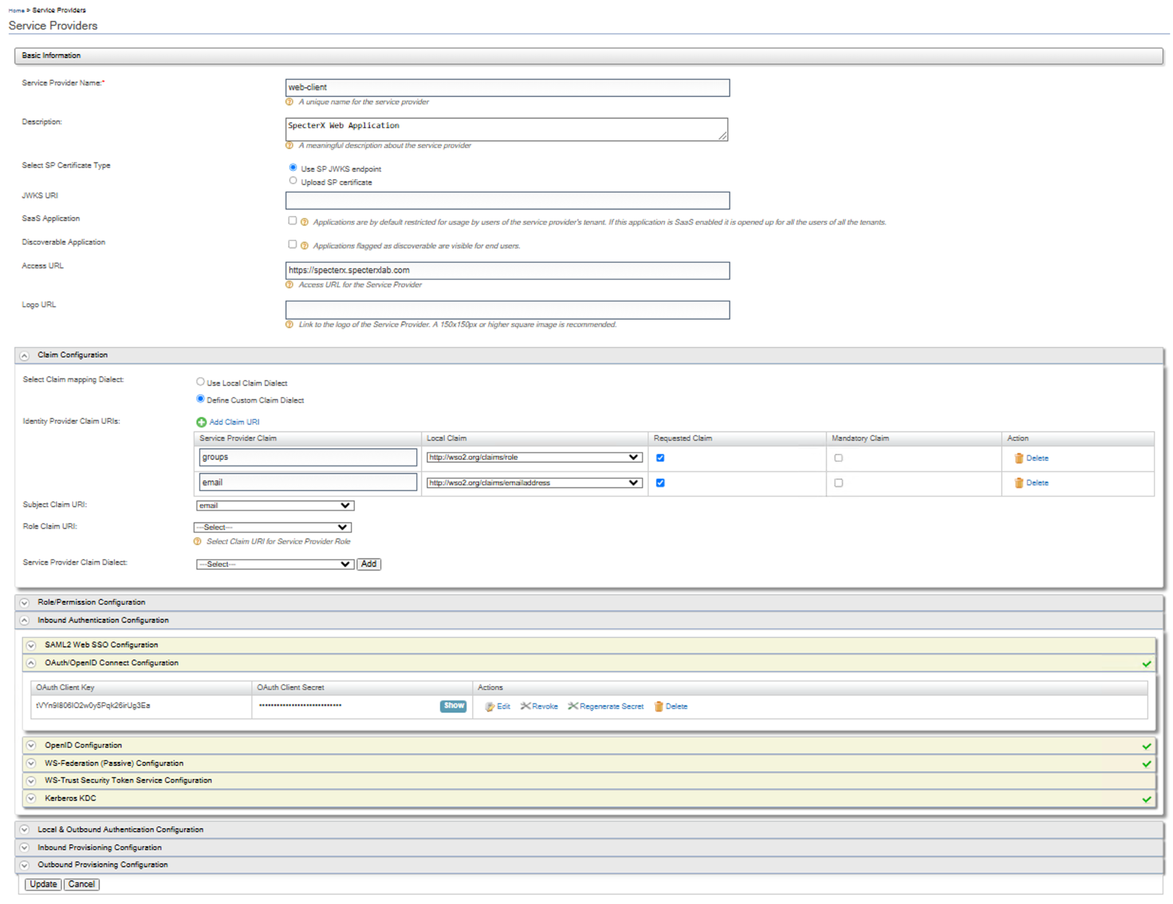
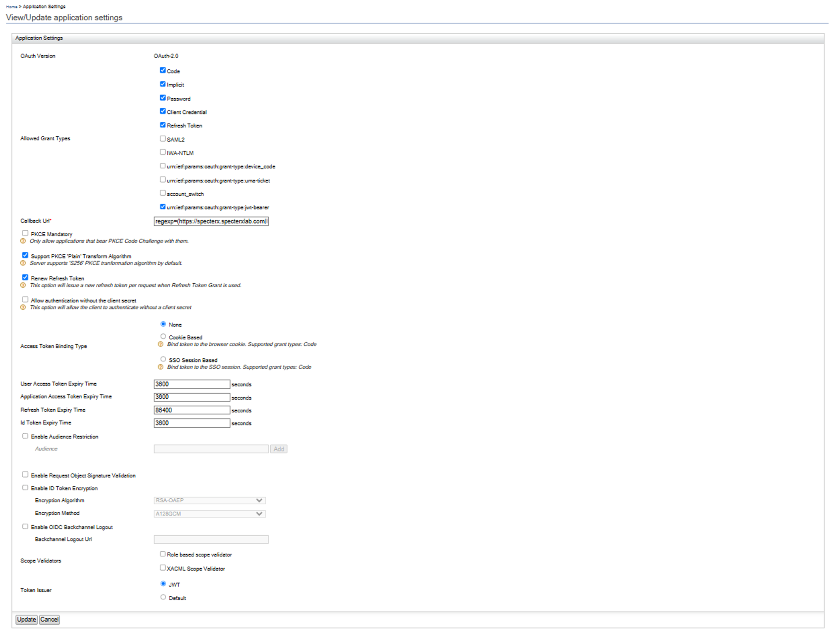
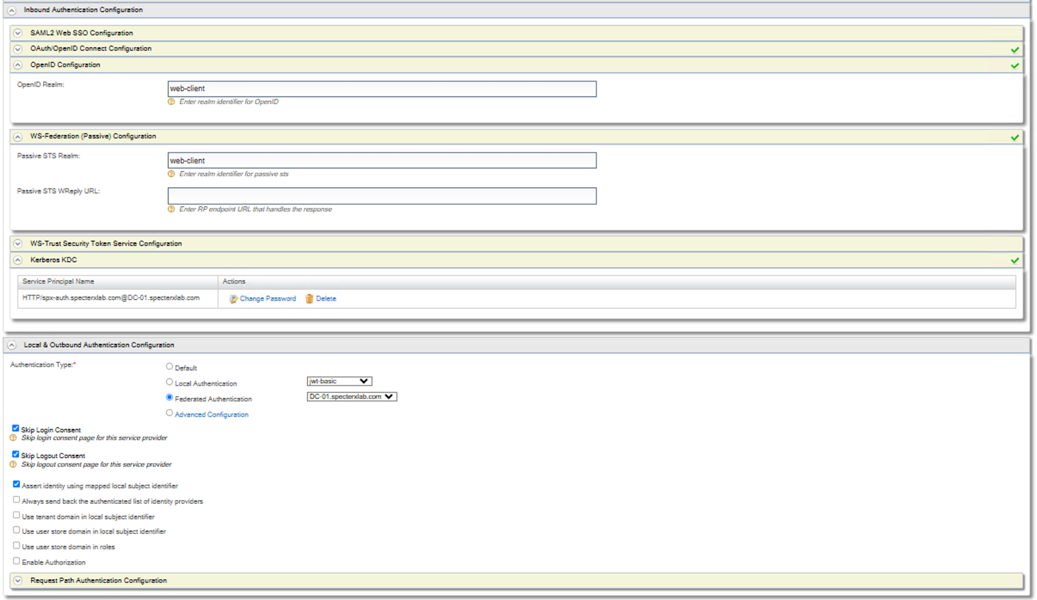

4.4. Update Claim Configurations
On the left-hand side of the screen, locate the ‘Claims’ section and click on ‘List’.
Select http://wso2.org/claims from the list.
Use the following table as a reference while you update the claim configurations:
Claim Name | Setting Name | Value
Email | Display Name | Email
 | Description | Email Address
 | Mapped Attribute(s) | User Store Domain Name Mapped Attribute  <Organization-Domain-Name> (I.E - specterxlab.com) mail
 | Regular Expression | ^([a-zA-Z0-9_\.\-])+\@(([a-zA-Z0-9\-])+\.)+([a-zA-Z0-9]{2,4})+$
 | Display Order | 6
 | Supported by Default | True
 | Required | True
Role | Display Name | Role
 | Description | Role
 | Mapped Attribute(s) | User Store Domain Name Mapped Attribute  <Organization-Domain-Name> (I.E - specterxlab.com) role
 | Regular Expression | Leave empty
 | Display Order | 0
 | Supported by Default | True
 | Required | True

The following figures show a valid configuration (For SpecterXlab.com domain)
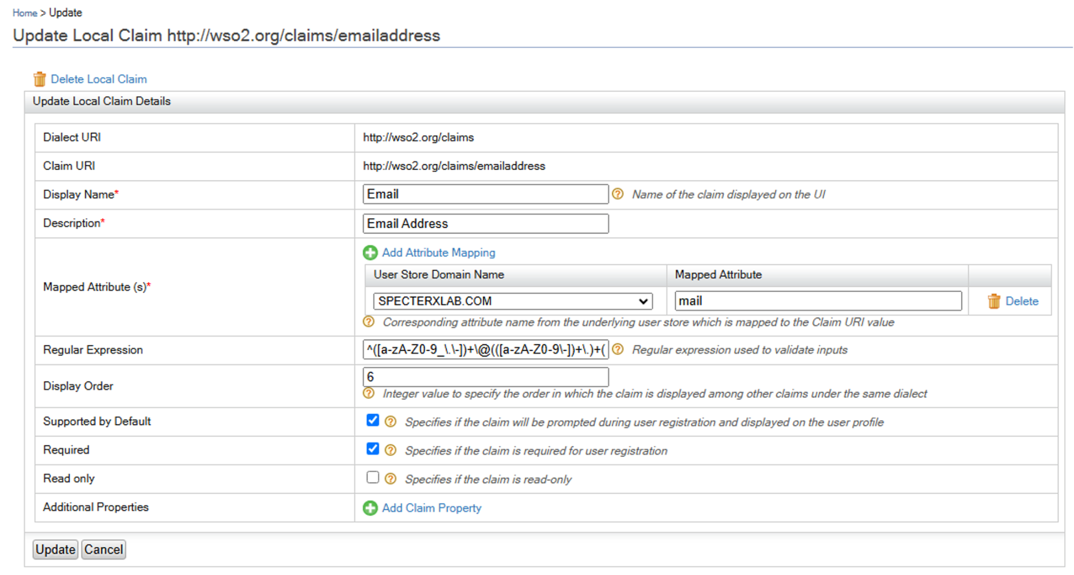

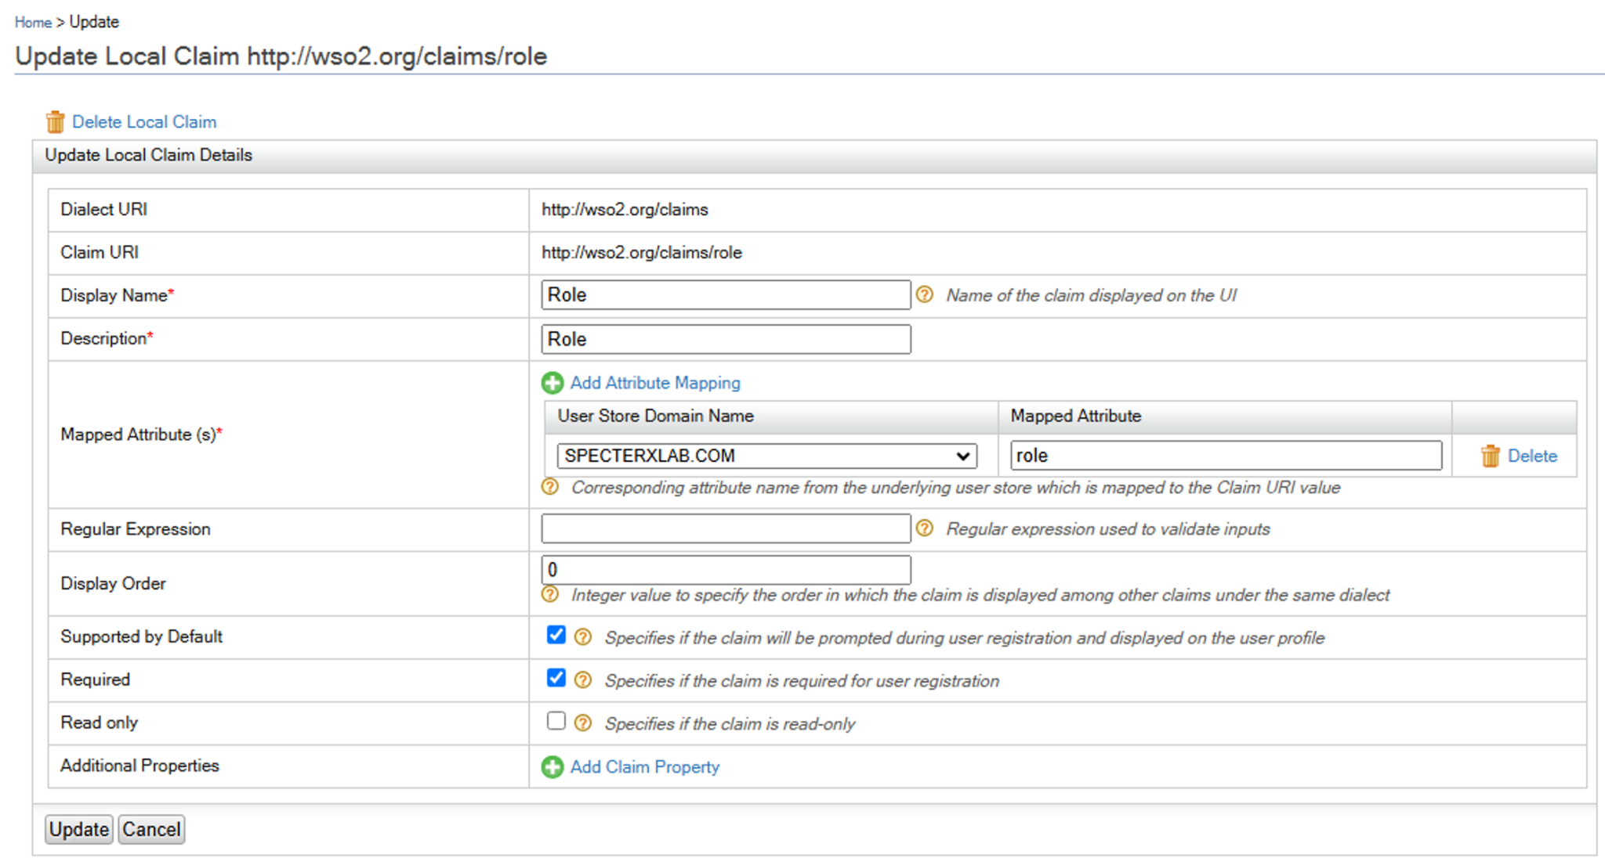

5. Export WSO userstores - Active Directory XML connection scheme
This step is crucial to make sure we keep the AD connection settings persistent:
# validate the path is empty with exsiting XMLs if needed, rm them
sudo docker cp wso2:/home/wso2carbon/wso2is-5.10.0/repository/deployment/server/userstore /opt/specterx/conf/
# validate with
sudo su
ls -l /opt/specterx/conf/userstores/
Change file permissions to match wso2 internal service user:
sudo chown -R 802:802 /opt/specterx/conf/*

Validate with ls -l, it should look like this:
Edit the docker-compose.yml file
nano /opt/specterx/docker-compose.yml
Uncomment the relevant line in the docker compose file, to pass that file to the container.
- /opt/specterx/conf/userstores:/home/wso2carbon/wso2is-5.10.0/repository/deployment/server/userstores

Restart the container and validate:
cd /opt/specterx && docker compose down wso2 && docker compose up -d wso2
#or
docker stop wso2
docker rm wso2
docker compose up -d wso2
docker logs -f wso2


6. Update Web-Client Repository
On the left-hand side of the screen, locate the ‘Service Providers’ section and click on ‘View’, select the newly created ‘Web-client’.
Locate the ‘Inbound Authentication Configuration’ section, Expand ‘OAuth/OpenID Connect Configuration’.
Copy the ‘OAuth Client Key’ and OAuth Client Secret’, Update the ‘WSO’ section on the ‘env.ts’ file (Web-Client repository)

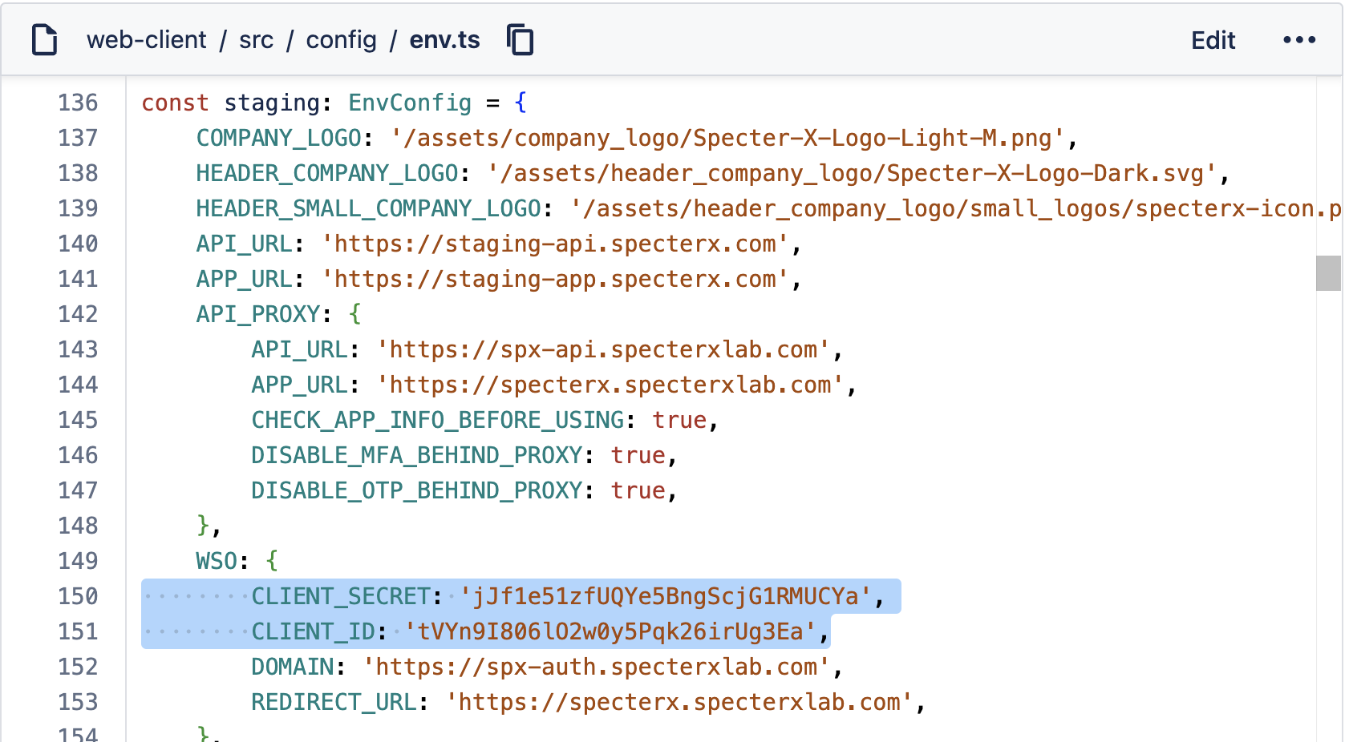

7. Client Settings:
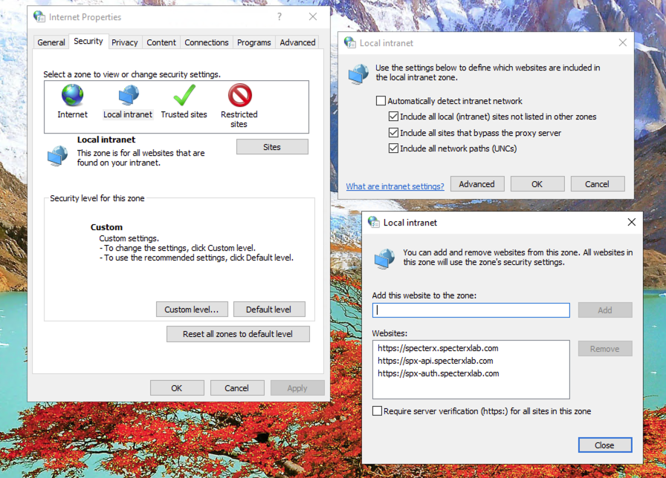
Validate internet settings allows SpecterX internal site and auto.: inetcpl.cpl
Security → Local intranet → Sites
https://spx-auth.DOMAIN
https://spx-api.DOMAIN
https://specterx.DOMAIN

passing of username and password:

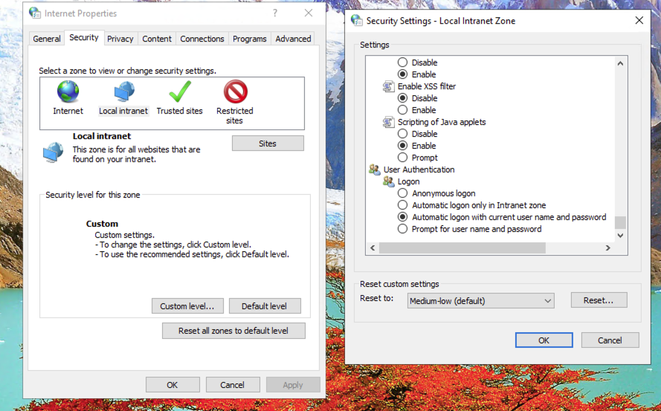
Use Chrome without certificate validation, if we don't have a valid CA and Certificates:
"C:\Program Files\Google\Chrome\Application\chrome.exe" --ignore-certificate-errors

